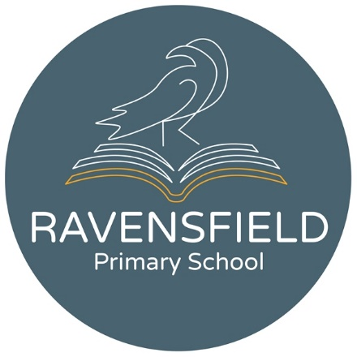

Ravensfield Primary School
Clarendon Street, Dukinfield, Cheshire,
SK16 4JG
Tel: 0161 344 2905
Head teachers: Mr O Kerr/Mrs H Heron

Temporary KS2 Class Teacher

Start Date: October 2026
Contract Type: 12 months FTC
Salary Grade: Main scale

Ravensfield Primary School is entering an exciting period of positive change. While the school has faced some challenges in recent times, there is a clear and determined focus on rapid improvement, with strengthened leadership, renewed ambition and a shared commitment to providing the very best education for our pupils. We are seeking an ambitious, skilled and dedicated Key Stage 2 teacher who is ready to play an active role in this journey. This post offers a genuine opportunity to make a meaningful impact, work alongside a supportive and motivated team, and help shape a school that is moving forward with confidence and purpose.

Only applications submitted on the CLIC Trust’s application form will be considered, please return the application form to: finance@ravensfield.tameside.sch.uk.

Closing Date: 9am on Thursday 9th July 2026
Shortlisting: from 9th July 2026
Interviews: Tuesday 14th July 2026

Safeguarding
The CLIC Trust is committed to safeguarding and promoting the welfare of children and young people and expects all staff and volunteers to share this commitment.
All appointments are subject to satisfactory references and DBS checks.

Equality
The CLIC Trust is a Cooperative Trust and does not discriminate on the basis of any individual’s protected characteristics and encourages applications from all qualified applicants. We pride ourselves on being a flexible and inclusive employer. We celebrate difference, embrace diversity and support all our people to thrive at work.

