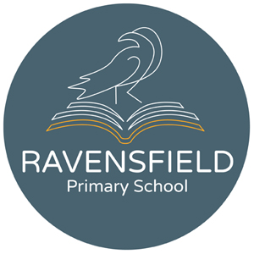
Clarendon Street, Dukinfield, Cheshire,
SK16 4JG
Tel: 0161 344 2905
Fax: 0844 292 7655
Head teacher: Miss K Leyland
12th November 2020

Dear Parents and Carers,

Due to the need to further improve social distancing in our kitchen, we will be introducing new menus from the 30th November. If you have pre-booked orders from 30th November to 18th December, these will need to be re-booked. Sorry for any inconvenience this may cause. For those who have already paid for these orders, refunds have been made and your account sits in credit.

We kindly request that parents support their children and school by choosing the dinners. This lets the children eat the things you are happy for them eat and means school is not wasting food or money by over or under ordering.
Thanks for your help and understanding and sorry again for any inconvenience caused by this change.

Karen Leyland
Heateacher

