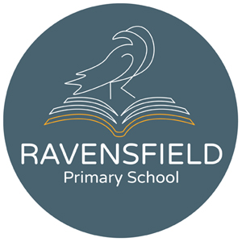
Clarendon Street, Dukinfield, Cheshire,
SK16 4JG
Tel: 0161 344 2905
Fax: 0844 292 7655
Head teacher: Miss K Leyland
10th February 2020

Dear Parent/Guardian,
To celebrate and encourage a lifelong love of reading at home and school, we will be running a sponsored read during the half-term holiday. The project is being organised in conjunction with Usborne books, and all the money raised will go towards brand new books for our school.
In addition to the sponsorship money, Usborne will also donate up to 60% of the total raised in EXTRA FREE BOOKS to the school. So for every £600 raised, we will get an extra £360 in FREE Usborne books!
Please help us to enhance our reading resources for pupils by encouraging your child to spend some time each day either reading to themselves, to others, or being read to. They can read books, comics, magazines, newspapers, menus, websites, recipes, poems, leaflets, instructions - anything at all!
If you are able to support our sponsored read, please find enclosed a sponsorship form for your child. Please ask family and friends to sponsor your child either for each minute they spend reading, or else a set amount for the whole week.
A reading log, to record the minutes they have spent reading, will be given to them in time for the holidays.
After the sponsored read, please send all the sponsorship money that your child has raised into school by Wednesday 26th February.
We look forward to sharing our grand total with you and having lots more books for your child to read, share and enjoy.
Your faithfully,
Mrs Light and Mr Pugh

