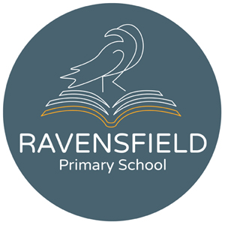
Clarendon Street, Dukinfield, Cheshire,
SK16 4JG
Tel: 0161 344 2905
Fax: 0844 292 7655
Head teacher: Miss K Leyland
20/4/20
Dear Parents/carers,
Today is the 11th day that many children will not be attending school. We now know lock down will continue for at least the next 3 weeks and so whilst it is very important that children feel safe and secure during this time, it is also important to keep doing some learning too.
Every week the teachers at Ravensfield put new activities on our school website. Once on our school website, click on 'curriculum' then select 'school work' from the drop down menu and everything you need is there. This information has also been sent out as a text.
Please make sure your child spends time every day doing some of these activities and a variety is always best. We suggest at least 3 activities at day. One could be a reading or a writing activity, another could be a maths activity and the third could be another subject. Teachers have put links on to other sites such as BB Bitesize and the link to this has been sent out in a text to parents previously. Once your child has completed some work it can be emailed to the teacher again via the website.
If you have any concerns about work, your child's teacher or teaching assistant will be telephoning at least once a fortnight. You can also email any time via the school website.
We want all our children to remain safe and happy and well and well prepared for when school does re-open. Doing some learning at home will help with all these things.
Thanks for all your help and for supporting school during this time. We hope to see you all again very soon.
Kind regards,

Karen Leyland
Headteacher

