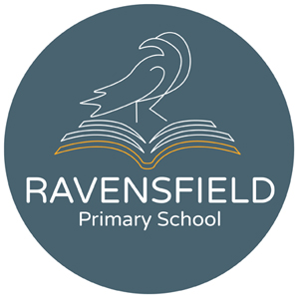
Clarendon Street, Dukinfield, Cheshire,
SK16 4JG
Tel: 0161 344 2905
Fax: 0844 292 7655
Head teacher: Miss K Leyland


Dear Parents & Children

Hope you have all had a lovely summer break and ready to return to school, I just wanted to share with you all, my exciting but sad news. At the beginning of the summer holidays an opportunity came up for a new position at another school in a different borough, I was successful and have taken the position meaning unfortunately I will not be returning to Ravensfield at the start of the new school year in September. I am sorry to have to tell you via a letter due to the current situation.

Ravensfield has been a huge part of my life for the last 13 years, I have worked closely with all you lovely children and families and built up some very good relationships. For that I just want to say thank you. Thank you for letting me into your life and working with me, thank you for making me smile in watching you grow from strength to strength and thank you for making me feel proud that you have achieved the best you can, and I know you will all continue to do so as I leave.
I am going to miss everyone so very much but always remember there is always someone at school to listen to you and help and support you should you ever need it.

I will look forward to hearing all the great stories about how well the children are doing as well as my families. I have lots of happy memories that will stay with me in my heart forever.

It has been an absolute pleasure being part of Ravensfield and one I will never forget.

Take care, stay safe and be strong. Keep smiling 😁 every day is a new day 😁
Mrs Cooper

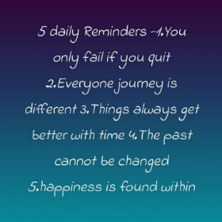  Watch Mrs Cooper’s video here.

