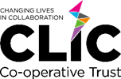
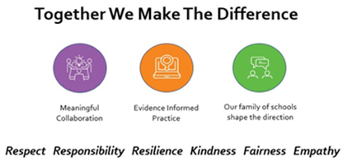
Admissions Policy Overview Statement
Document Control
Title | Admissions Policy Overview Statement
Date | September 2026
Date of next review | July 2027
Approval Level | Trust Board
Supersedes | September 2025
Amendments
Related Policies/Guidance | School Admissions Code 2021  School Admission Appeals Code  School Standards and Framework Act 1998.
Author | Chief Executive Officer
Policy Category | Statutory  Trust Wide: this policy applies to all schools within the Trust

Introduction
Chorlton Park Primary School (Manchester), Crosslee Community Primary School (Manchester), Dane Bank Primary School (Tameside), Lily Lane Primary School (Manchester), Old Moat Primary School (Manchester), Ravensfield Primary School (Tameside) and Rolls Crescent Primary School (Manchester) are all academies that are part of The Changing Lives In Collaboration Trust (the Trust).
The Trust is the admissions authority for the schools and is therefore responsible for ensuring that these arrangements are compliant with the Admissions Code 2021. It is the responsibility of the Trustees of the CLIC Trust to draft, consult on and determine the admission arrangements of all academies within the trust.
Under the terms of the co-ordinated admissions scheme, the LA is responsible for co-ordinating the admission of all children to Manchester and Tameside schools and academies. The CLIC Trust schools all follow their Local Authorities’ determined admissions arrangements.
Each school publishes admissions arrangements on their school website. These arrangements aim to provide information on: how to apply for a place at the school; how places are allocated; and how to appeal against a decision not to offer a child a place. The published admission arrangement documents are based on the following guidance from the Department for Education:
- School Admissions Code 2021
- School Admission Appeals Code
As an academy, each school is required by its funding agreement to comply with these codes, and with the law relating to admissions, as set out in the School Standards and Framework Act 1998.

Consultation
Admission authorities must consult when admission arrangements are changed or if they have not been consulted on within the last 7 years. Admission authorities must consult for a minimum period of 6 weeks and must take place between 1 October and 31 January in the determination year. As a Trust, we take part in all Local Authority admissions consultations. We are next due to consult on our arrangements as a Trust in October 2026. During this consultation, we will ask for feedback from governors, parents/carers, staff, the local authorities, neighbouring local authorities and other key stakeholders.

